Name : Jay Sandeep Chatpalliwar

PRN : 21510018

Assignment 11 – SSL using Wireshark packets

Q1] For each of the first 8 Ethernet frames, specify the source of the frame (client or server),

determine the number of SSL records that are included in the frame, and list the SSL record

types that are included in the frame. Draw a timing diagram between client and server, with

one arrow for each SSL record.

Ans-

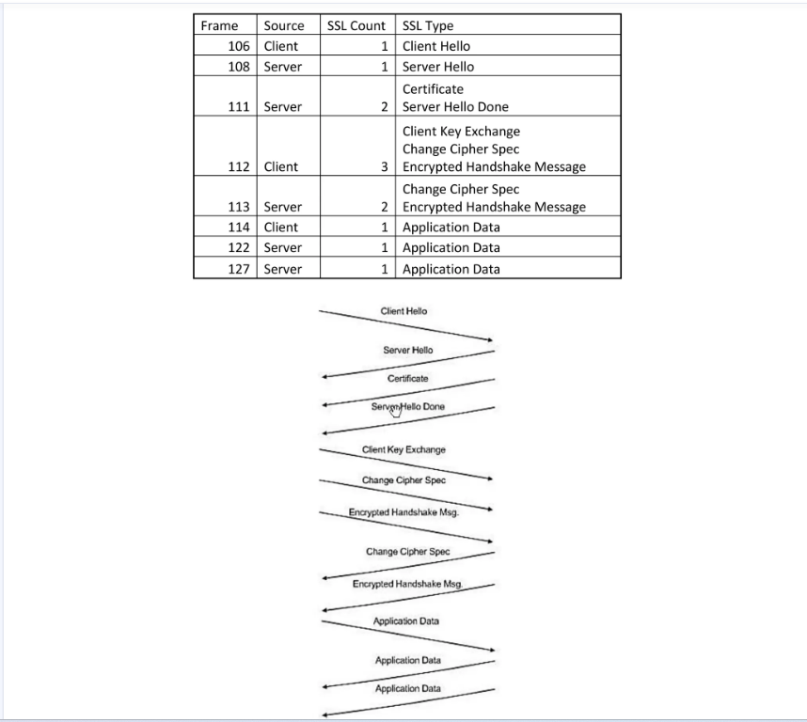

Q2] Each of the SSL records begins with the same three fields (with possibly different values).

One of these fields is “content type” and has length of one byte. List all three fields and their

lengths.

Ans-

Content Type : 1 byte

Version : 2bytes

Length : 2bytes

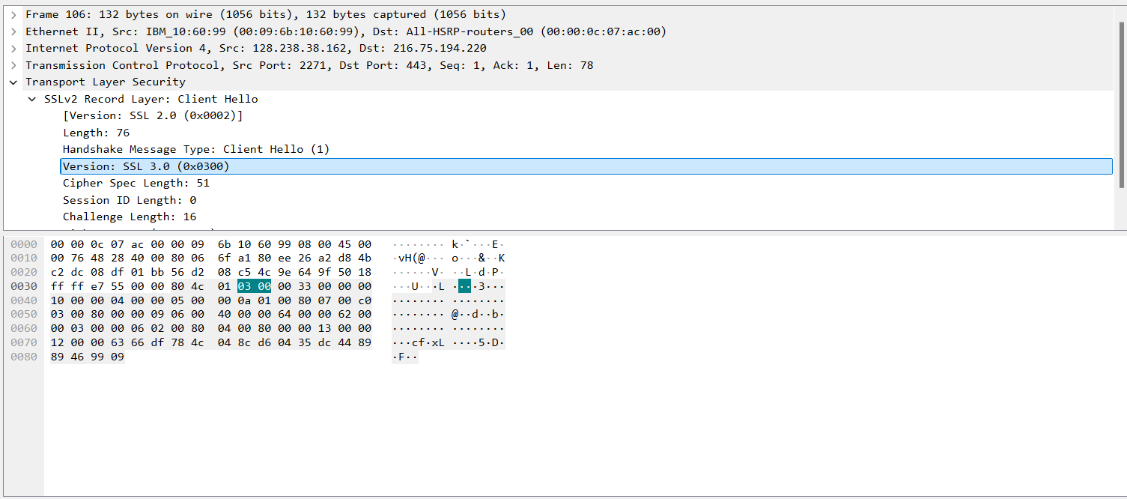

Q3] Expand the ClientHello record. (If your trace contains multiple ClientHello records, expand

the frame that contains the first one.) What is the value of the content type?

Ans- The content type is 22,for Handshake message ,with a handshake type of 01,Client Hello.

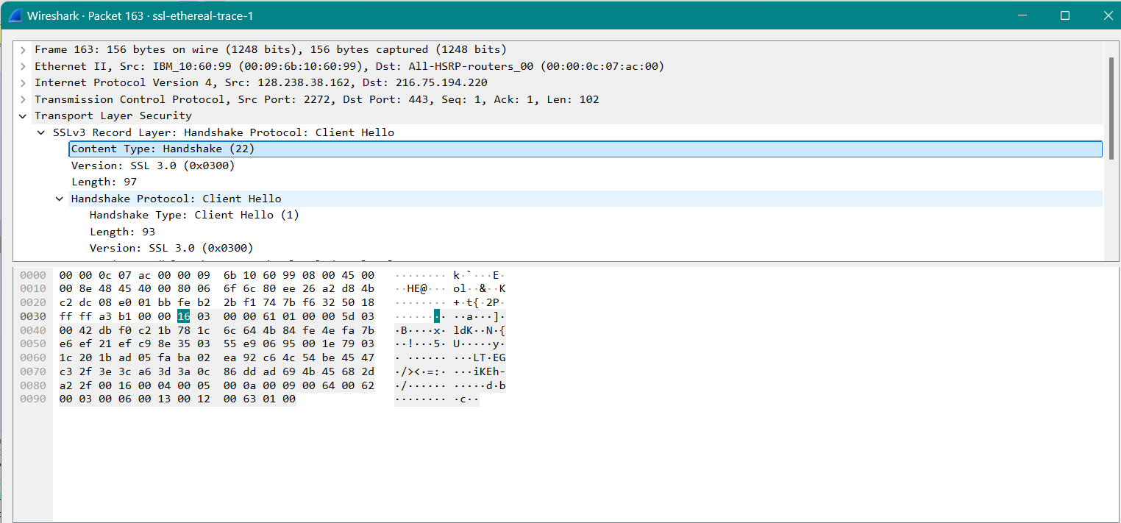

Q4] Does the ClientHello record contain a nonce (also known as a “challenge”)? If so, what is the value of the challenge in hexadecimal notation?

Ans-The client hello challenge is –

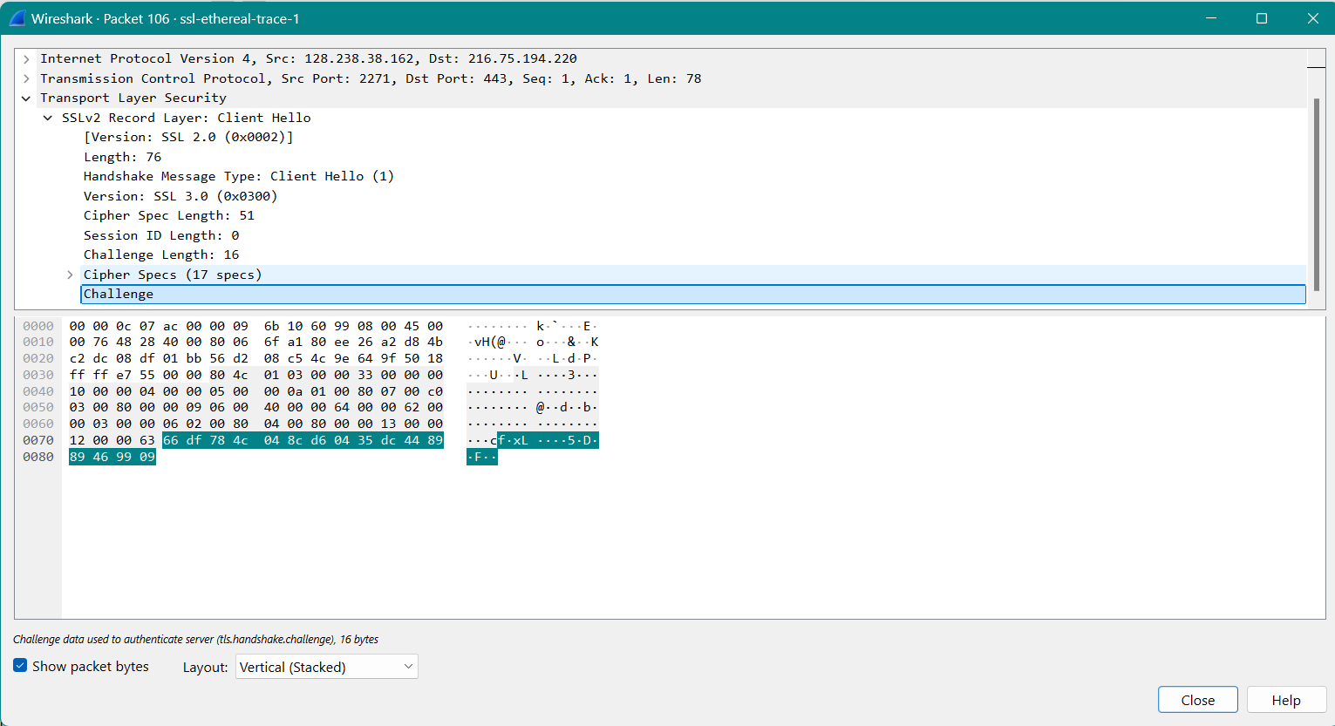

Q5] Does the ClientHello record advertise the cyber suites it supports? If so, in the first listed suite, what are the public-key algorithm, the symmetric-key algorithm, and the hash algorithm?

Ans-The first suite uses RSA for public key cryptograpgy,RC4 for the symmetric-key cipher and uses MD5 hash algorithm.

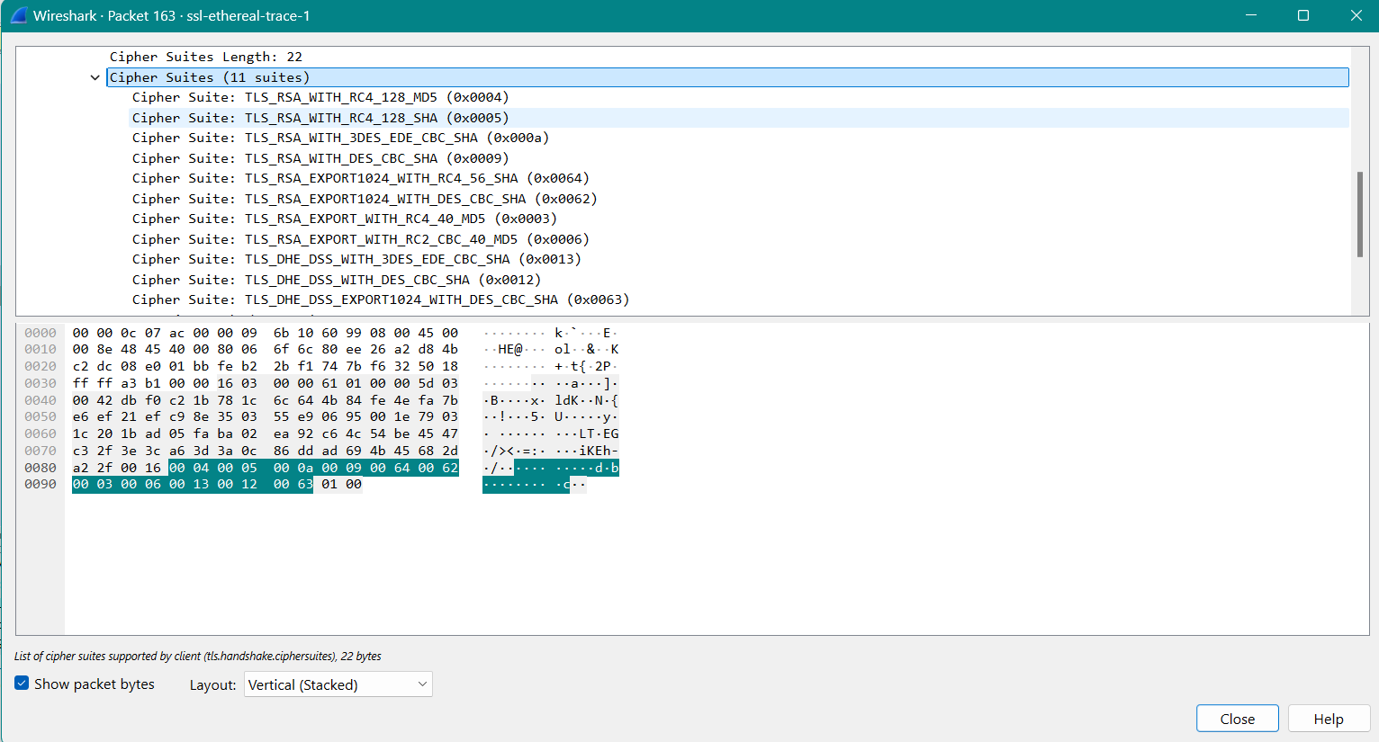

Q6] Locate the ServerHello SSL record. Does this record specify a chosen cipher suite? What are the algorithms in the chosen cipher suite?

Ans- The first suite uses RSA for public key cryptograpgy,RC4 for the symmetric-key cipher and uses MD5 hash algorithm.

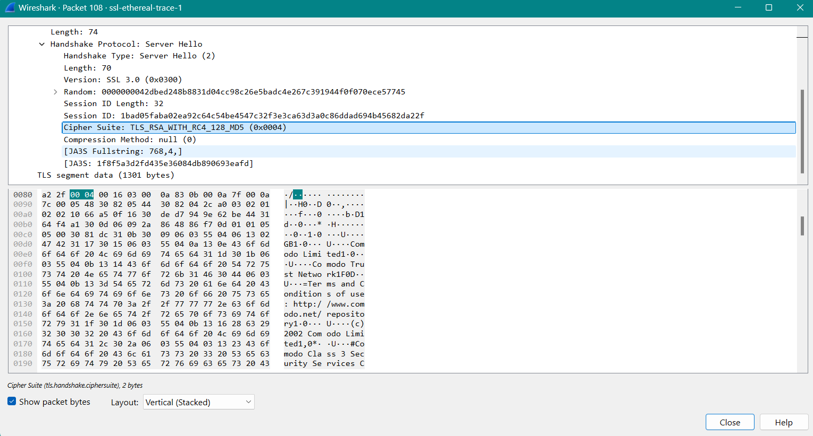

Q7] Does this record include a nonce? If so, how long is it? What is the purpose of the client and server nonces in SSL?

Ans-Yes,the record includes nonce listed under random.The nonce is 32 bits long,28 for the data and 4 for the time.The purpose is to prevent replay attack.

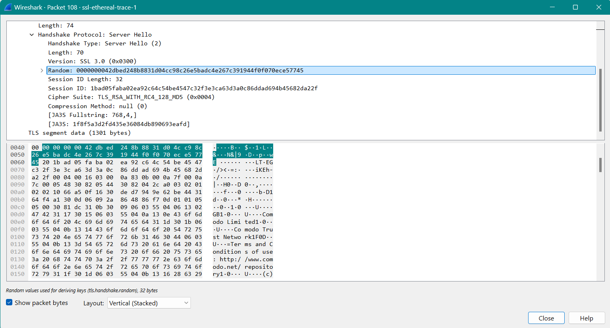

Q8] Does this record include a session ID? What is the purpose of the session ID?

Ans- Yes,it provides a unique persistent identifier for the SSL session which is sent.The client may resume the same session later by using the server provided session id when it sends the ClientHello.

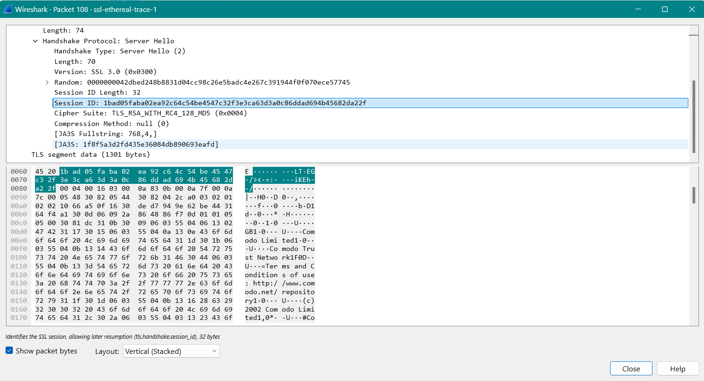

Q9] Does this record contain a certificate, or is the certificate included in a separate record. Does the certificate fit into a single Ethernet frame?

Ans-There is no certificate it is another record.It fits into a single ethernet frame.

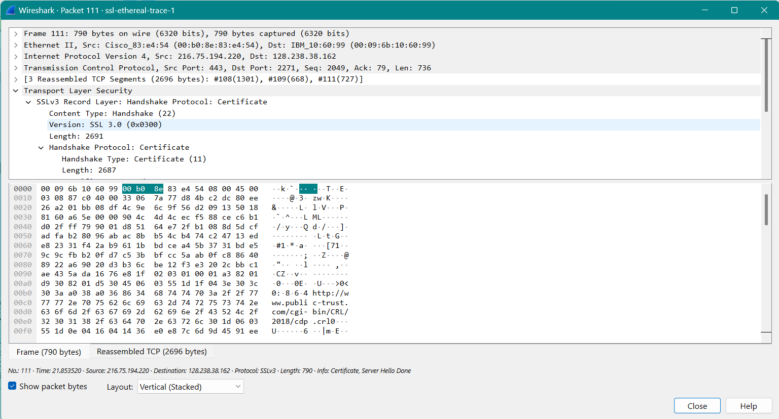

Q10] Locate the client key exchange record. Does this record contain a pre-master secret? What is this secret used for? Is the secret encrypted? If so, how? How long is the encrypted secret?

Ans-Yes it contains a premaster secret.Used on both sides client and server to make a secret which is used to generate keys for mac and encryption.The server is encrypted with the public key of server,which cleient extracts from the certificate sent.

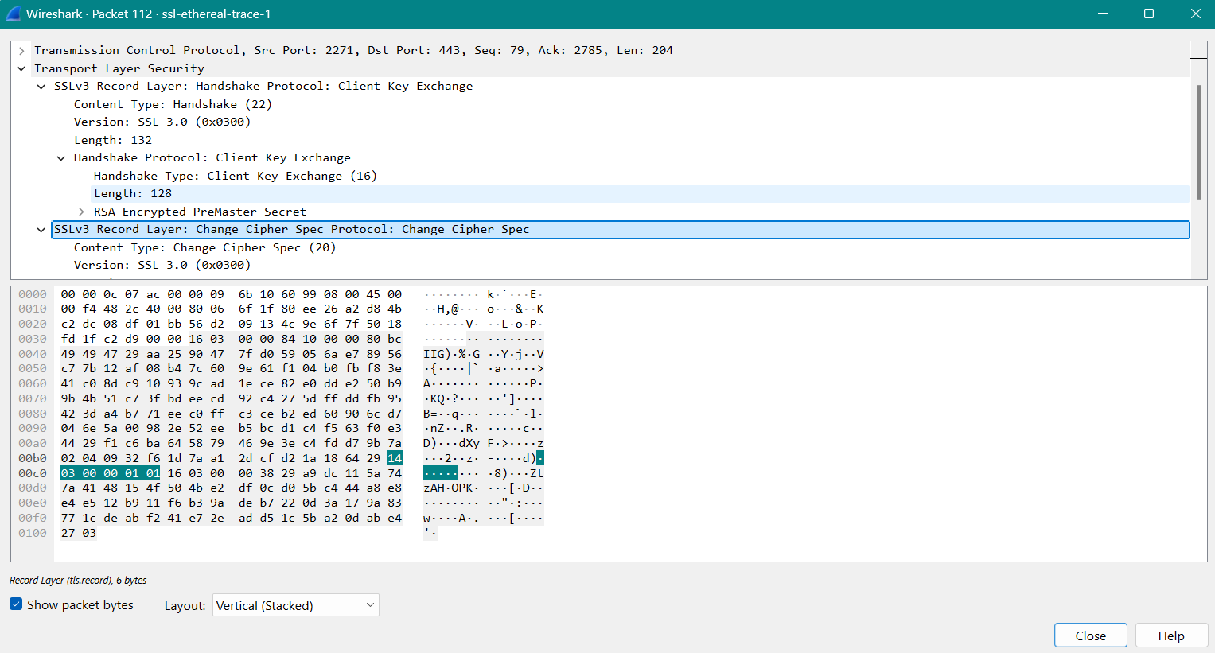

Q11] What is the purpose of the Change Cipher Spec record? How many bytes is the record in your trace?

Ans-The purpose of the Change Cipher Spec record is to indicate that the contents of the following SSL records sent by the client (data, not header) will be encrypted. This record is 6 bytes long: 5 for the header and 1 for the message segment.

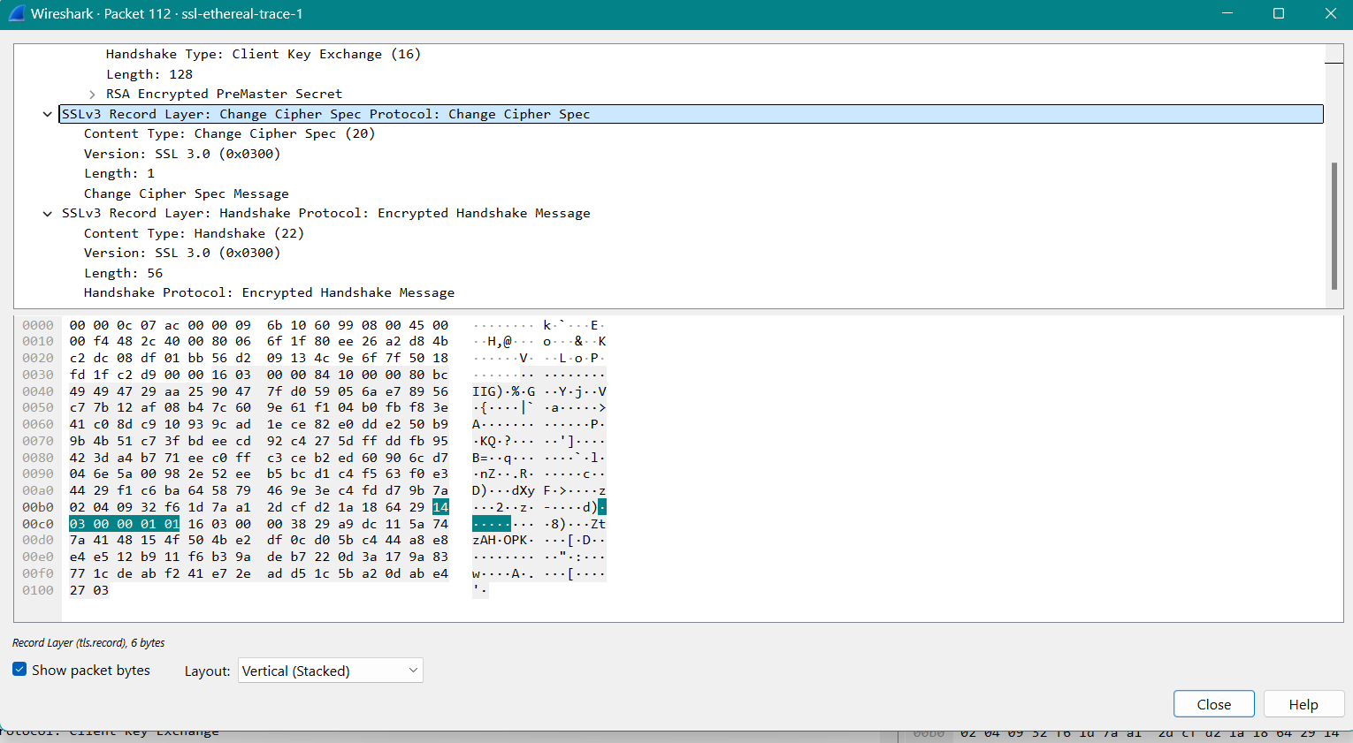

Q12] In the encrypted handshake record, what is being encrypted? How?

Ans-In the encrypted handshake record, a MAC of the concatenation of all the previous handshake messages sent from this client is generated and sent to the server.

Q13] Does the server also send a change cipher record and an encrypted handshake record to the client? How are those records different from those sent by the client?

Ans-Yes, the server will also send a Change Cipher Spec record and encrypted handshake to the client. The server's encrypted handshake record is different from that sent by the client because it contains the concatenation of all the handshake messages sent from the server rather than from the client. Otherwise, the records would end up being the same.

Q14] How is the application data being encrypted? Do the records containing application data include a MAC? Does Wireshark distinguish between the encrypted application data and the MAC?

Ans-Application data is encrypted using symmetric key encryption algorithm chosen in the handshake phase (RC4) using the keys generated using the pre-master key and nonces from both client and server. The client encryption key is used to encrypt the data being sent from client to server and the server encryption key is used to encrypt the data being sent from the server to the client.

Q15] Comment on and explain anything else that you found interesting in the trace.

Ans-NIL.